The apps focus is on the deadlines and timing of tasks. It gives users reminders during the right time to do a certain thing.

You can set repeating reminders, or one time reminders on a specific date. Repeating reminders can be every other day, or based on days of the week. The focus with repeating reminders is on building a routine you wish to stick to.

This is from my own experience – I use my alarm clock app to remind me about things i need to do, because some things need to be done during my lunch break, when I'm at home, or when I wake up.

Special feature – DO IN FUTURE – a task that may not have a set deadline, or have one that is far away – for example, watch this movie, read this book, apply for something next month,...

- can be both essential and non-essential. Think the “schedule” area on the “urgency-Importance” chart.

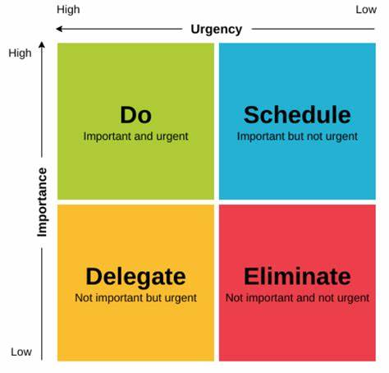

DO IN FUTURE tasks are put into the same pool. You can set a notification that reminds you of one of these tasks, prioritizing something that is due sooner, but is otherwise random.

The reminder feature would be complete if it could pull a task from the DO IN FUTURE pool, but also made sure that a feature would come up at least once before its due date. The reminders can be scheduled (say you have a few over the weekend), or triggered manually. (the user can tap a button to get a task from the pool)

Main page – schedule a task, or schedule a DO IN FUTURE task – 2 seperate screens where you can CRUD.

THEME

* A helpful cute goblin is keeping track of things for you. It manages your to do list, and makes entries based on what you tell it.

THOUGHT BUBBLES – intro:

“something on your mind? I can hold onto that thought for you! You’ll be able to see all the thoughts I’m holding above me in bubbles. “

* Completing a task will pop the bubble, along with a flashy animation and sfx, to give dopamine to the user
* The bubbles are set to remind you of their existence during your free time.

Include a cute companion – style idea:

Simple design, few colours.

(Bear from Animated google stickers)

- included as the introduction to the app – only some of the non-standart features, so that the tutorial isn’t annoying

- possibly a small animation of it lying down and dreaming up the bubbles from the thought bubble system

On Signup:

- The app asks you about when you are usually busy – default input is a timeframe, and a selection of weekdays – like alarm clock app. Alternatively, user can input their working hours, study hours, etc. Precicely. This changes as the user fills up their timetable.

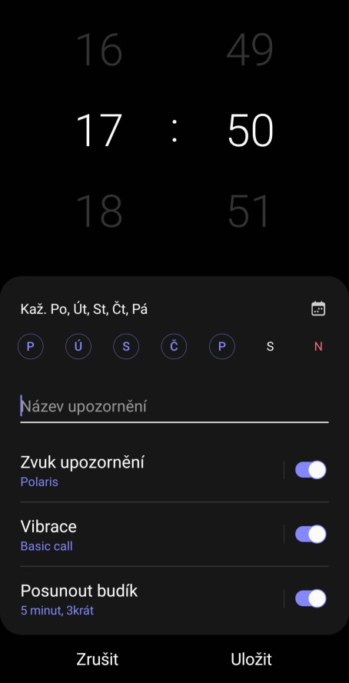Samsung alarm clock app – select days of the week, select time, name it, other ringtone settings do not apply.

Should the thought bubbles be organized based on how specific they are? Some of them could be very nebulous, while other that have a deadline could slot themselves into the calendar.

Slotting bubbles into the calendar – drag and drop? - might be a bit annoying on mobile when you want to scroll

Calendar view of organized thought bubbles – a bubble you set to remind you until a certain date would show up up to that date in the calendar view.

Big question – organization of thought bubbles